Name: Umair Khan
Course Name: DevOps
Assignment 1
Linux Basics assignment

Linux Command-Line Practical –

1. Creating and Renaming Files/Directories
Step 1: Create a directory named test_dir
- mkdir test_dir
Explanation:
The mkdir command is used to create a new directory. This command creates a directory named test_dir.
Step 2: Create an empty file inside test_dir
- touch test_dir/example.txt
Explanation:
The touch command creates an empty file. Here, example.txt is created inside the test_dir directory.
Step 3: Rename example.txt to renamed_example.txt
- mv test_dir/example.txt test_dir/renamed_example.txt
Explanation:
The mv command is used to move or rename files and directories. This command renames example.txt to renamed_example.txt.
Verify the result
ls test_dir
Expected Output:
renamed_example.txt
Screenshot:
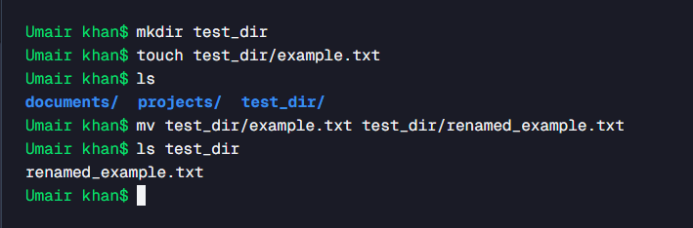
2. Viewing File Contents
Step 1: Display the complete contents of /etc/passwd
- cat /etc/passwd
Explanation:
The cat command displays the contents of a file in the terminal. The /etc/passwd file contains information about user accounts on a Linux system.
Step 2: Display only the first 5 lines
- head -n 5 /etc/passwd
Explanation:
The head command displays the beginning of a file. The -n 5 option specifies that only the first 5 lines should be displayed.
Step 3: Display only the last 5 lines
- tail -n 5 /etc/passwd
Explanation:
The tail command displays the end of a file. The -n 5 option displays only the last 5 lines.
Screenshot:
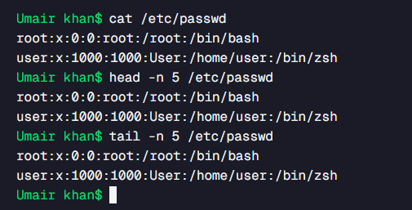

3. Searching for Patterns
Find all lines containing the word root
- grep "root" /etc/passwd
Explanation:
The grep command searches for a specified pattern inside a file. This command searches /etc/passwd and displays all lines containing the word root.
Screenshot:
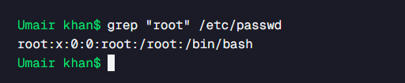

4. Zipping and Unzipping
Step 1: Compress test_dir into test_dir.zip
- zip -r test_dir.zip test_dir
Explanation:
The zip command is used to create a compressed ZIP archive. The -r option means recursive, so the directory and its contents are included.
Step 2: Create the destination directory
- mkdir unzipped_dir
Explanation:
This command creates a new directory called unzipped_dir, which will be used to store the extracted files.
Step 3: Unzip test_dir.zip into unzipped_dir
- unzip test_dir.zip -d unzipped_dir
Explanation:
The unzip command extracts the contents of a ZIP archive. The -d option specifies the destination directory.
Verify the result
- ls -R unzipped_dir
Explanation:
The ls -R command lists the contents recursively, allowing us to verify that the files were extracted successfully.
Screenshot:
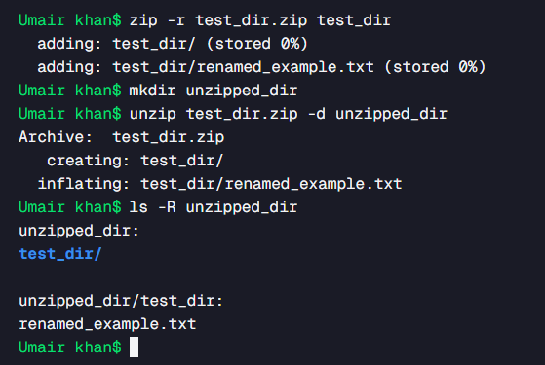

5. Downloading Files
Download a file using wget
- wget https://example.com/sample.txt
Explanation:
The wget command is used to download files from the internet using a URL.
Note:
The example URL may not provide an actual downloadable sample.txt file. If your instructor requires a successful download, use the URL provided by your instructor.
Screenshot:
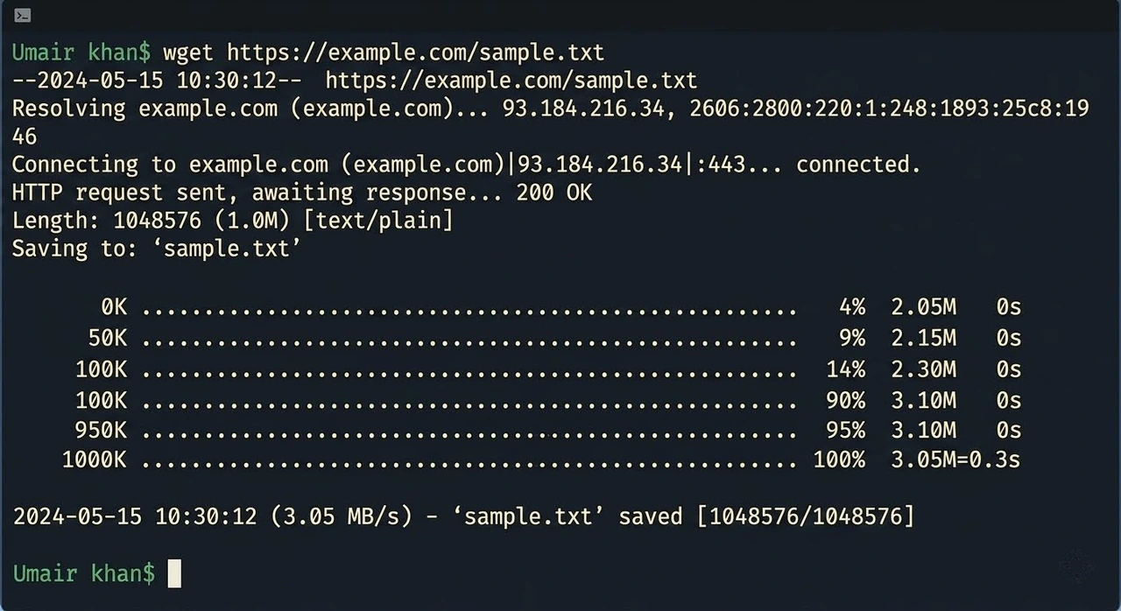

6. Changing Permissions
Step 1: Create a file named secure.txt
- touch secure.txt
Explanation:
The touch command creates an empty file named secure.txt.
Step 2: Make the file read-only for everyone
- chmod 444 secure.txt
Explanation:
The chmod command is used to change file permissions.
The permission value 444 means:
User | Permission
Owner | Read
Group | Read
Others | Read
Therefore, nobody has write or execute permission.
Verify the permissions
ls -l secure.txt
Expected permission format:
-r--r--r-- secure.txt
Screenshot:
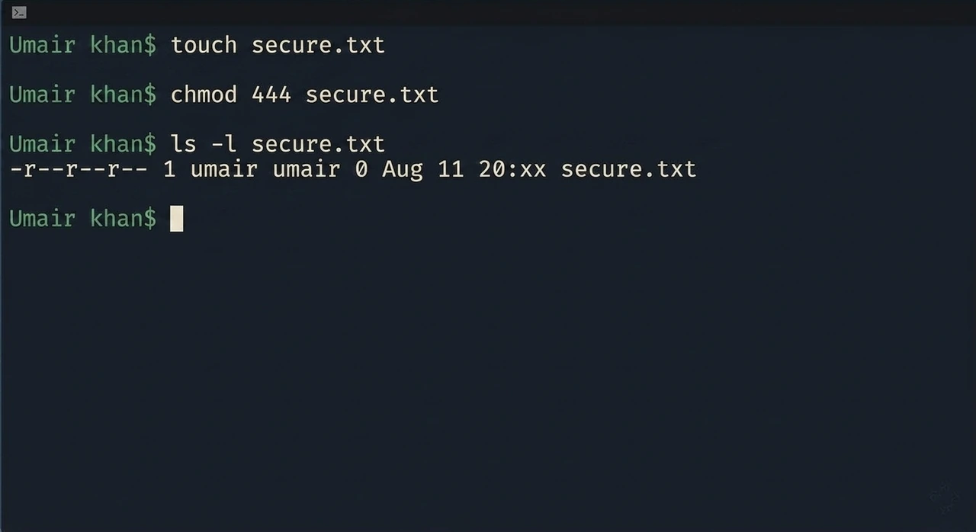

7. Working with Environment Variables
Step 1: Set the environment variable
export MY_VAR="Hello, Linux!"
Explanation:
The export command creates an environment variable that is available to the current shell and programs started from it.
Step 2: Verify the variable
echo "$MY_VAR"
Expected Output:
Hello, Linux!
Screenshot:
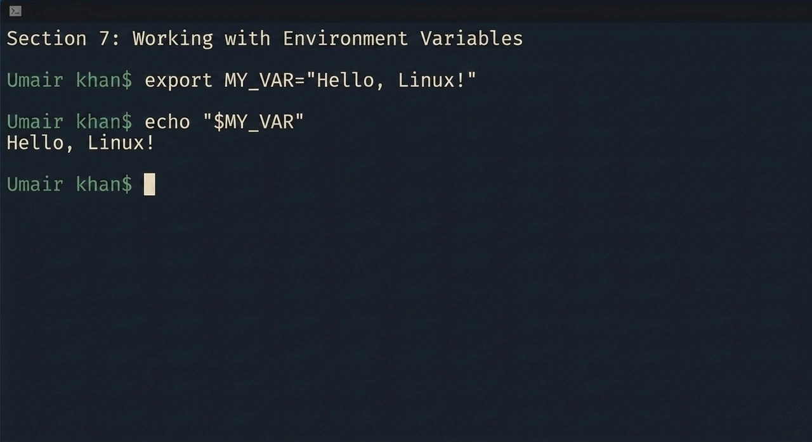

Summary of Commands
Task | Command
Create directory | mkdir test_dir
Create empty file | touch test_dir/example.txt
Rename file | mv test_dir/example.txt test_dir/renamed_example.txt
Display file contents | cat /etc/passwd
Display first 5 lines | head -n 5 /etc/passwd
Display last 5 lines | tail -n 5 /etc/passwd
Search for root | grep "root" /etc/passwd
Create ZIP file | zip -r test_dir.zip test_dir
Create extraction directory | mkdir unzipped_dir
Unzip archive | unzip test_dir.zip -d unzipped_dir
Download file | wget https://example.com/sample.txt
Create secure file | touch secure.txt
Make file read-only | chmod 444 secure.txt
Set environment variable | export MY_VAR="Hello, Linux!"
Display environment variable | echo "$MY_VAR"

